Filming Meeting Template



## Meeting Lead: [Your Name]

###### Objective: Review the script, film the project, and transfer footage to a computer before the meeting ends.

### 1. Opening & Attendance (3 Minutes)

###### • Welcome & Overview: [Briefly introduce today’s filming session.]

###### • Attendance Check: [Personnel Manager takes attendance.]

###### • Plan for the Day:

###### • Script Review – Go over lines, scenes, and shot list.

###### • Filming – Head out and shoot the necessary footage.

###### • Footage Transfer – Return in time to upload clips to a computer.

### 2. Script Review & Final Prep (7 Minutes)

###### • Script Read-Through: [Go over the script with actors and crew.]

###### • Shot List & Scene Breakdown: [Confirm order of filming and key shots.]

###### • Equipment Check: [Ensure cameras, mics, and tripods are ready.]

###### • Roles Assignment: [Assign camera operators, actors, and crew positions.]

### 3. Filming Session (15 Minutes)

###### • Head to Filming Location: [Move to the designated area.]

###### • Execute the Shot List: [Film the necessary scenes efficiently.]

###### • Review Key Takes (if time allows): [Check for any reshoots needed.]

### 4. Footage Transfer & Wrap-Up (5 Minutes)

###### • Return to the Meeting Area: [Ensure all equipment is accounted for.]

###### • Transfer Footage to Computer: [Upload clips to an organized folder.]

###### • Confirm Next Steps: [Discuss editing timeline and assign tasks if needed.]

###### • Wrap-Up & Dismissal: [Thank members for their work and confirm any follow-ups.]

### End of Meeting

###### • Objective Completed: Script reviewed, footage filmed, and clips transferred.

###### • Next Steps: [Schedule editing session or assign editors for the project.]

Editing Meeting Template

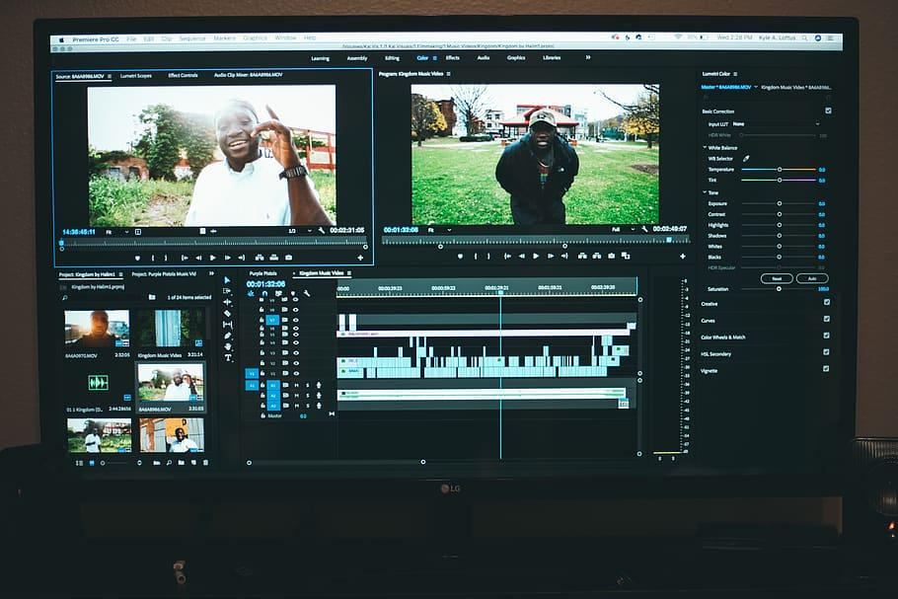

## Meeting Lead: [Your Name]

###### Objective: Fully edit the film from a previous week.

### 1. Opening & Attendance ([X] Minutes)

###### • Welcome & Overview: [Briefly introduce the purpose of today’s meeting.]

###### • Attendance Check: [Personnel Manager takes attendance.]

###### • Meeting Goals: [Explain the main objectives for the session.]

### 2. Peer Review of [Project Name] ([X] Minutes)

###### • Initial Viewing ([X] Minutes)

###### • [Watch the full project without interruption.]

###### • Structured Feedback ([X] Minutes)

###### • Story & Message: [Does it effectively communicate its purpose?]

###### • Editing & Transitions: [Are the cuts smooth and well-paced?]

###### • Audio & Music: [Is the sound balanced and clear?]

###### • Overall Impact: [Does it achieve the intended effect?]

###### • Prioritizing Changes ([X] Minutes)

###### • [Identify the most important edits needed.]

###### • [Assign editing tasks as necessary.]

### 3. Assigning Final Edits & Next Steps ([X] Minutes)

###### • Junior Editors: [Assign tasks for final edits and set deadlines.]

###### • PR Advisor: [Ensure project aligns with FPCTV’s quality standards.]

###### • Confirm Submission Deadline: [Set a date and method for final approval.]

###### • Upcoming Projects (if time allows): [Preview any future assignments.]

### End of Meeting

###### • Wrap-up & Dismissal: [Thank members and confirm action items.]